**Connecting to Hyper-V host remotely (No-domain(WORKGROUP))**

To Manage

* Hyper-V Core (CMD)
* Hyper-V Platform (Windows DC Edition)

**Server Configuration (Hyper-V host)**

* Enable Remote Management (For Hyper-V Manager)
* Enable Remote Desktop
* Set Computername (Hostname)
* Enable WSMan and PS-Remoting:

Type in **cmd.exe**:

Enable-PSRemoting

Enable-WSManCredSSP -Role server

**Client Configuration (Hyper-V Manager)**

Run Notepad in Administrator mode. Open the following file: C:\Windows\System32\Drivers\etc\hosts.

Append the following:  
<Hyper-V Host IP> <Hyper-V Hostname>

Set Connection Profile (Ethernet Interface connected to the Hyper-V Server) to “Private”

In **Windows PowerShell**:

Get-NetAdapter|Get-NetConnectionProfile

Set-NetConnectionProfile -InterfaceAlias Ethernet -NetworkCategory Private

Configure the client to allow connection to the server by adding the server as a trusted host for the [WS-Management Protocol](https://msdn.microsoft.com/en-us/library/aa384470(v=vs.85).aspx).

Note: Stopping the winrm service after the configuration is alright.

Enable-PSRemoting

Start-Service -Name winrm

Set-Item WSMan:\localhost\Client\TrustedHosts -Value <Server Hostname>

Enable-WSManCredSSP -Role Client -Delegate <Server Hostname>

Enable Group Policy for Delegating credentials:

Group Policy -> Computer Configuration -> Administrative Templates -> System -> Credential Delegation -> Allow delegating fresh credentials with NTLM-only server authentication :

Enable and Add Server:

**Wsman/<hostname>**

**Helpful Commands:**

To test out that you can authenticate to and remotely run commands from your workstation by testing Invoke-Command

Invoke-Command {whoami} -ComputerName <Remote HostName> -Credential <Remote Hostname>/<Remote Admin ID>

Enable Hyper-V Management Tool in windows feature to get the hyper-v manager GUI installed

**To get around the authorization error**

Manually add the Hyper-V Server credentials into memory using cmdkey.

cmdkey /add:HYPERV-SERVER /user:Administrator /pass:<REDACTED>

Proceed to login without specifying the username and password.

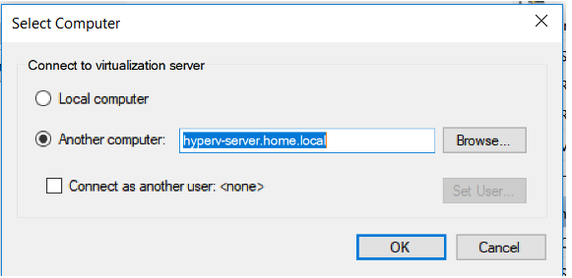

Reference: <https://blog.ropnop.com/remotely-managing-hyper-v-in-a-workgroup-environment/>